LAB REPORT

for
Lab Assignment #0:
Switches & Seven-Segment Display

Document description:
This document gives a detailed lab report for the Lab Assignment #0.

Table of contents:

1. Introduction 1
2. Design Context 1
3. Design of Controller Components 1
4. In Lab Test 1
5. Conclusion 1

1. Introduction
This document describes a trivial lab assignment (a simple design tutorial) to be
conducted the first week of classes, before we have even had time to teach about logic
gates, except for the NOT gate, which was briefly introduced in the first lecture.
However, it engages students in working with the real board hardware and seeing real
outputs right away. At a circuit level, it is very simple, and this may help students to
more easily understand what they are doing when they are just starting to learn Quartus.
It does not include a pre-lab report requirement, because students in the Monday lab
section will not have had a chance to prepare a pre-lab report between the first lecture and
lab. However, it does include a simple design component and a lab report requirement.
-- quoted from Lab Assignment #0 document.

2. Design Context
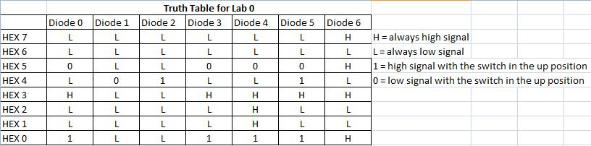

This truth table (above) describes the logic behind the 7 segment display on the birthdates of the two team members. Not only should the 6 digit dates be taken into account, but the 7 segments of each digit should as well. Luckily, not too many signals had to be switched due to the birthdates being so similar; however the logic is as illustrated by the table above.

System-level functional requirement. If the switch is up, the seven segment display shows team member 1’s birth date. If the switch is down, the seven segment display shows team member 2’s birth date.

Table 1. This table lists the two possible situations that may exist and the required behavior of the system in each one.
Situations |  | Behaviors
Sit.  # | Switch is up | Show person 1 birth date | Show person 2 birth date
1 | no | yes | no
2 | yes | no | yes

5. Design of Controller Components
Show below is the schematic created in Quartus for the seven segment display.
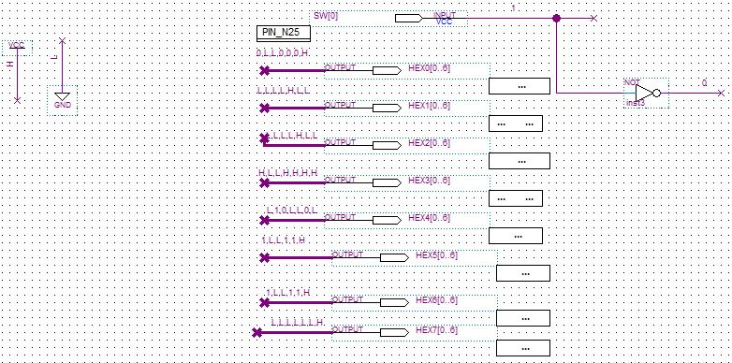
Note that the above design has the properties as illustrated in the truth table on page 1.

6. In Lab Test
At first, the given circuit board was having some malfunctions and problems, so that board was switched out. Next the program was compiled and sent to the board; however the dates were not printed correctly. In fact, the 7 segments were printed inversely. This problem was then easily fixed by switching the H’s to L’s and vice versa.

7. Conclusion
As this was the first lab, many new concepts and lessons were learned. We familiarized ourselves with DE2 boards, Quartus 2 software, LED controls, 7segment display controls, and lab notebook/report convention.
In this assignment, we learned the following important lessons (these are just made-up for example purposes; you yourself may have learned other lessons in addition to these, depending on what kind of mistakes, if any, you ran into in your design):

(1) The top-level design process is an effective way to break down design problems.
(2) The right top-level system architecture can make the detailed design much simpler.
(3) The use of Boolean Algebra identities can help to simplify a gate-level design.
This ensures that students understand how to go through a complete design
cycle before they start creating more complex designs.)
figure out exactly how each of these dates will be represented on the 8-digit,
seven-segment LED numeric display.
birth dates of the two team members – lucky it was both in august

